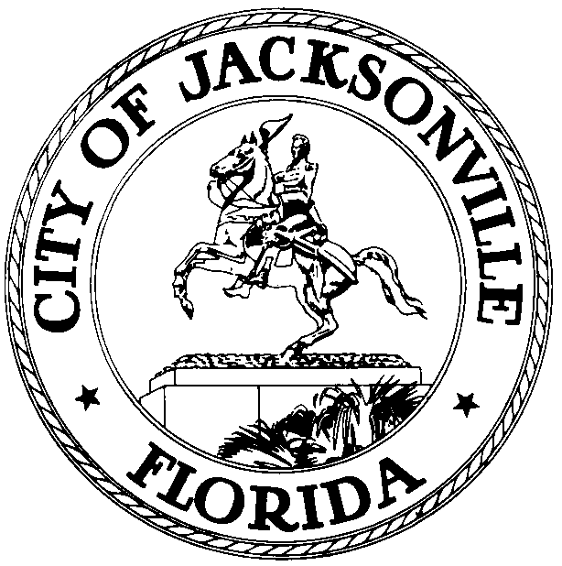

OFFICE OF THE CITY COUNCIL

LORI N. BOYER 117 WEST DUVAL STREET, SUITE 425
2016 – 2017 PRESIDENT 4TH FLOOR, CITY HALL
OFFICE (904) 630-1382 JACKSONVILLE, FLORIDA 32202
FAX (904) 630-2906
E-MAIL: LBOYER@COJ.NET
July 7, 2016
(12:00 P.M.)

NOTICE

M E M O R A N D U M

TO: City Council Members and Staff

FR: The Honorable Lori N. Boyer
Jacksonville City Council

RE: 2016-2017 Council Agenda and Council Meeting Notification
________________________________________________________________________

Notice is hereby given that The Honorable Lori N. Boyer, President, Jacksonville City Council is hereby calling the Council Agenda Meeting of the Jacksonville City Council, to be held at 4:00 pm on the 2nd and 4th Tuesday of every month. Additionally, the Jacksonville City Council will meet at 5:00 pm on the 2nd and 4th Tuesday of the month. Council Agenda and Council Meetings will be held in the Council Chamber located at 117 West Duval Street, 1st Floor City Hall – St. James Bldg., Jacksonville, Florida 32202. These meetings will take place at the times above unless there is a holiday, upon which the meetings will be pushed back 24 hours.

Please mark your calendars accordingly. All interested parties are invited to attend.

If you have any questions, please contact Legislative Services Division at (904) 630-1404.

LNB/CLB/clo

xc: Council Members/Staff Media Box
Cheryl L. Brown, Director/Council Secretary File Box
Carol Owens, Interim Chief- Legislative Services Div Mayor’s Office
Jeff Clements, Chief of Research
Office of the General Counsel
CITYC@COJ.NET
Electronic Notice Kiosk – 1st Floor City Hall
Public Notice System – City Council Web Page

